Llamaindex Project Setup

Simple Q|A System using OpenAI API

Navigate to the directory you want and open the folder in VSCode

Create an environment



Activate the environment



Create a new file ‘requirements.txt’

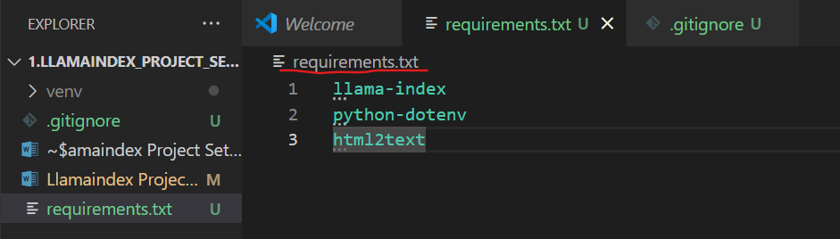

Install the requirements.txt



Create a new file called ‘.env’ and inside that paste the OpenAI api key

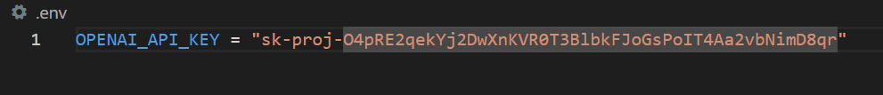

Create another two files directoryreader.py and webpagereader.py

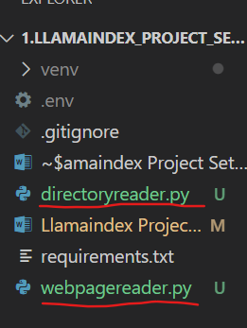

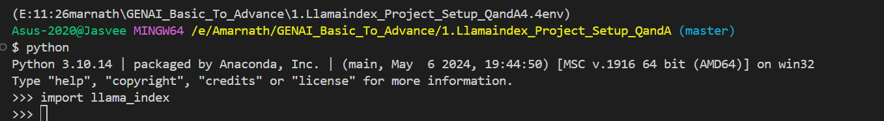

Import the necessary libraries

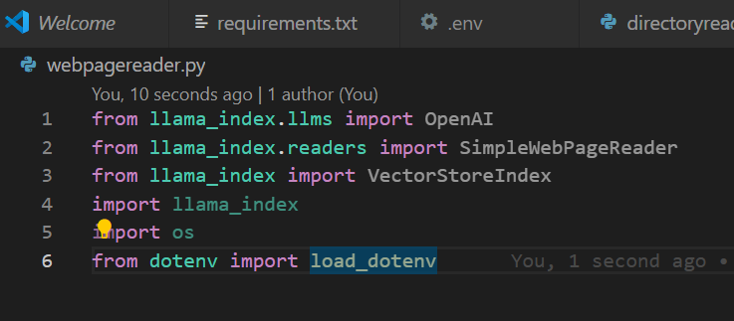



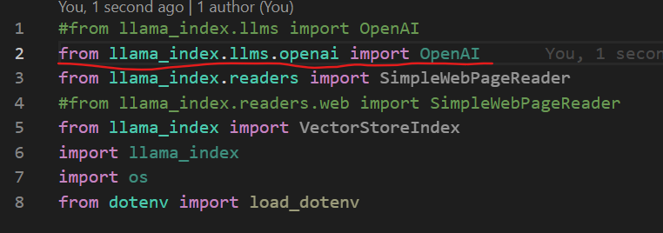



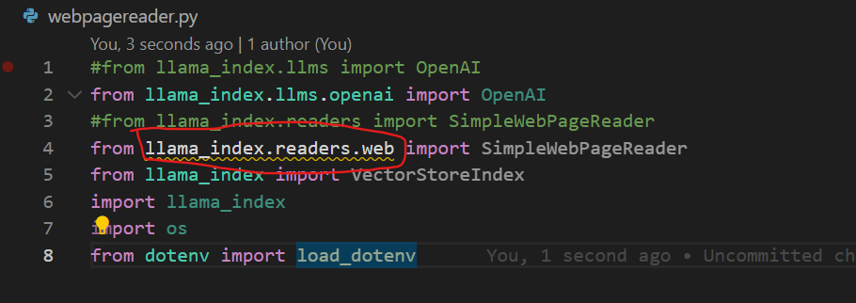

Install the pypy package of llama_index.readers.web

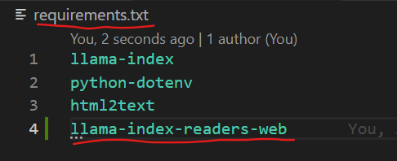



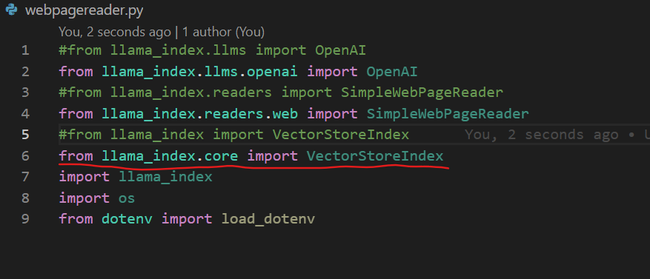



Now everything is working good

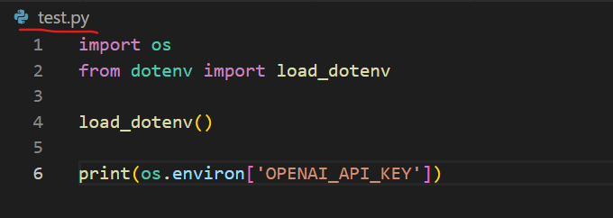



Now lets read the web page.

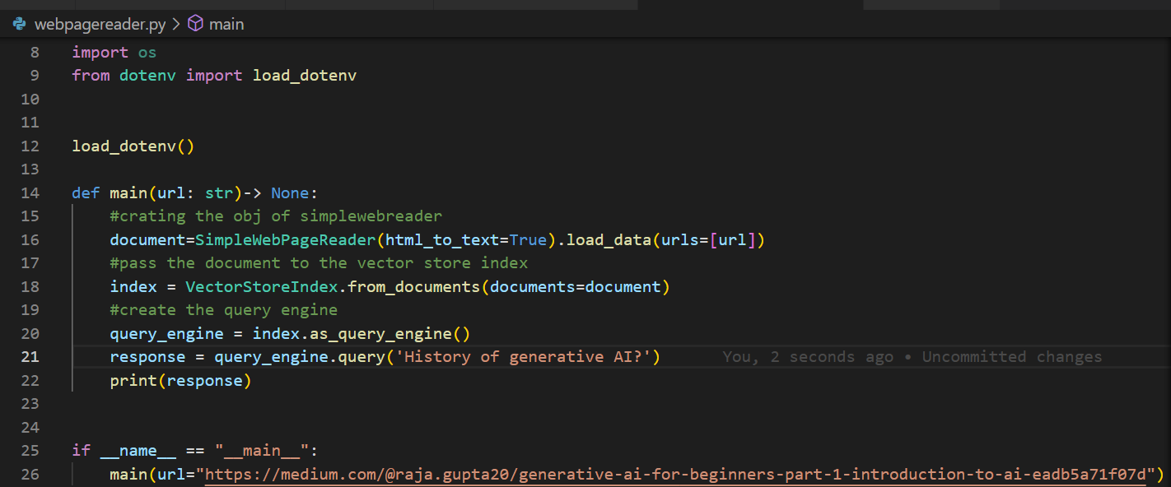

Pass any kind of URL and ask any sort of questions

If you run the file then you will get the answer

Directoryreader.py

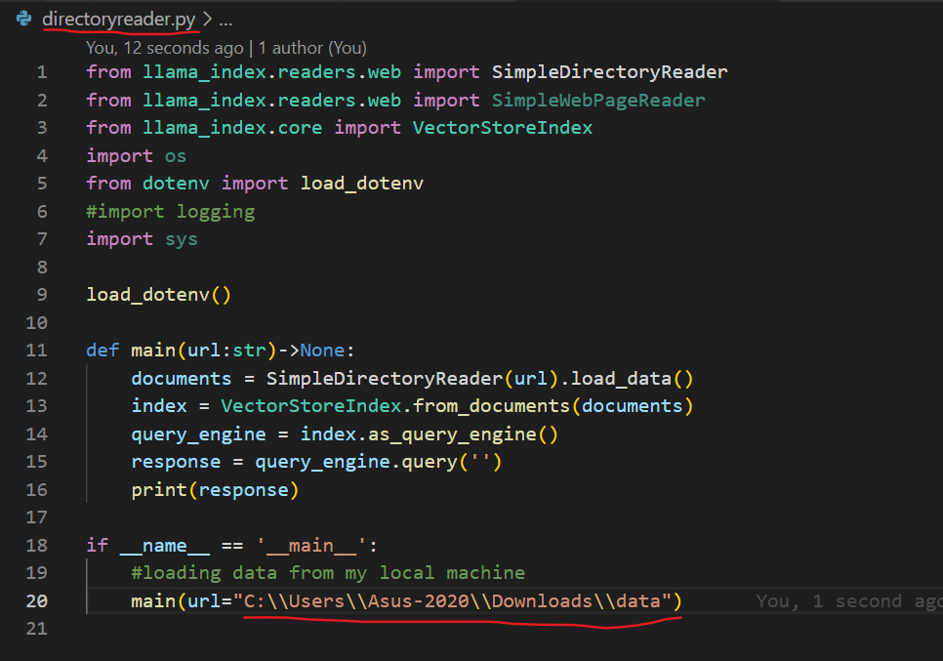

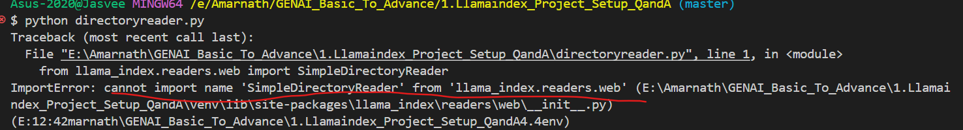

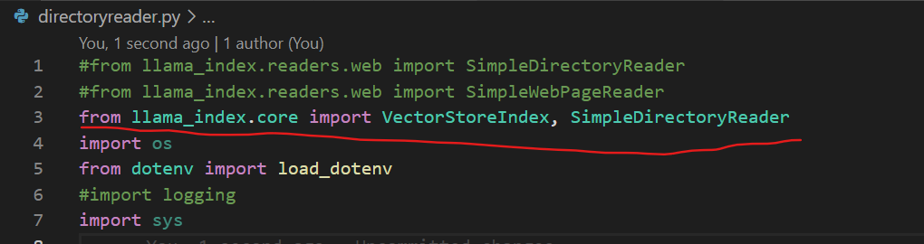

If run the file then you will get the response